Model abstract
Márcio Soares Pereira^{a)} and Marco Antonio Chaer Nascimento^{b)}
- Instituto de Química, Universidade Federal Rural do Rio de Janeiro, Brasil; ^{b)} Instituto de Química, Universidade Federal do Rio de Janeiro, Brasil

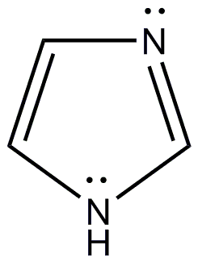
This is a model abstract. Please follow the layout specified here. Use New Times Roman font. The title is in 16 points font size and bold, all other text is in 12 points font. The abstracts will be reduced in size when they are printed and therefore a smaller font will be difficult to read. The original page size should be set to A4 (210 by 297 mm) as the Book of Abstracts will be printed in B5 size. The margins should be 3.0 cm on all edges. The text must be justified. Please indent the first line of each paragraph.
The abstract must fit on one page. References are cited in text like this [1]. The references are given in the format used by the Journal Progress in Theoretical Chemistry and Physics as shown below.
Formulas are shown in the center of the page as is shown here. If the formulas need to be numbered the numbers should be placed to the right in parentheses. Formula (1) shows the structure of imidazol. The same applies to mathematical formulas.

(1)

Illustrations may be added to the abstract. The building in Figure 1 is the conference site. The location is shown on the map which you can find at the web site of conference. Please visit http://www.qscp18.iq.ufrj.br/index.php

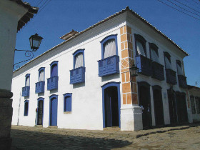

Figure 1. Casa da Cultura

[1] Jean Maruani, Progr. Theor. Chem. & Phys. B 19, 3-32 (2009).

